3
Darkroom

Black and white
Since its inception, with the first daguerreotype, photographies were captured in black and white by million of photographers. Today, with modern digital cameras, all the photos are shot in color but most, if not all, cameras allow to convert the image to black and white or sepia tone by enabling an option in a menu. However, sometimes a photo has an entirely different mood when seen in black and white and that's why many photographers want to convert their images to black and white.
 | The daguerreotype  In the first half of the nineteenth century, precisely in 1839, Louis Daguerre, presented his new invention to the public. This revolutionary discovery consisted in exposing a brass plate to the light in a properly built wooden box, called the “black chamber” which contains a lens that let the light hit the plate. A tiny stratus of silver were applied to the plate to sensitize it to the light. This process produced a latent image, that is an image that must be developed to form the final picture.
Capturing black and white photos force a different point of view for photographers, because human beings see in color and the world is full of color, but a black and white images is only defined by contrast between light and shadows.
Why someone may want to shoot in black and white ? The answer is multi-faceted : for example, to concentrate on shapes and discard “unuseful” information (like color) or to underline the force of shadows and light for a particular composition. For any reason, this workflow explain how to do convert an image to black and white (B/W from nows on) with darktable.

Perception of color by human eye
The light is part of the electromagnetic spectrum visible by the human eye. This part is only a fraction of the entire spectrum, as shown in Figure 1.

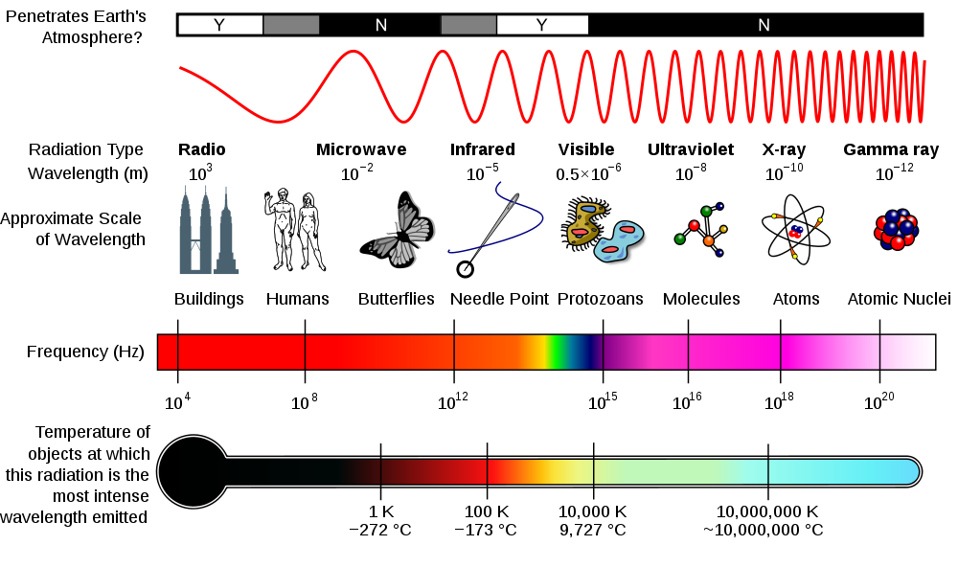Figure 1: The electromagnetic spectrum

In particular the human eye can see the wavelenghts between around 400 and 780 nanometers (nm) or, in terms of colors, from violet to red. The retina, which is the light-sensitive tissue inside the eye, is scattered of rods and cones. The former are concentrated at the outer edges of the retina and are used in peripheral vision, working better in dim light, for example at night. The cone cells work at best in bright light and are situated in the fovea, leaving the place to rods in peripheral parts of the retina.
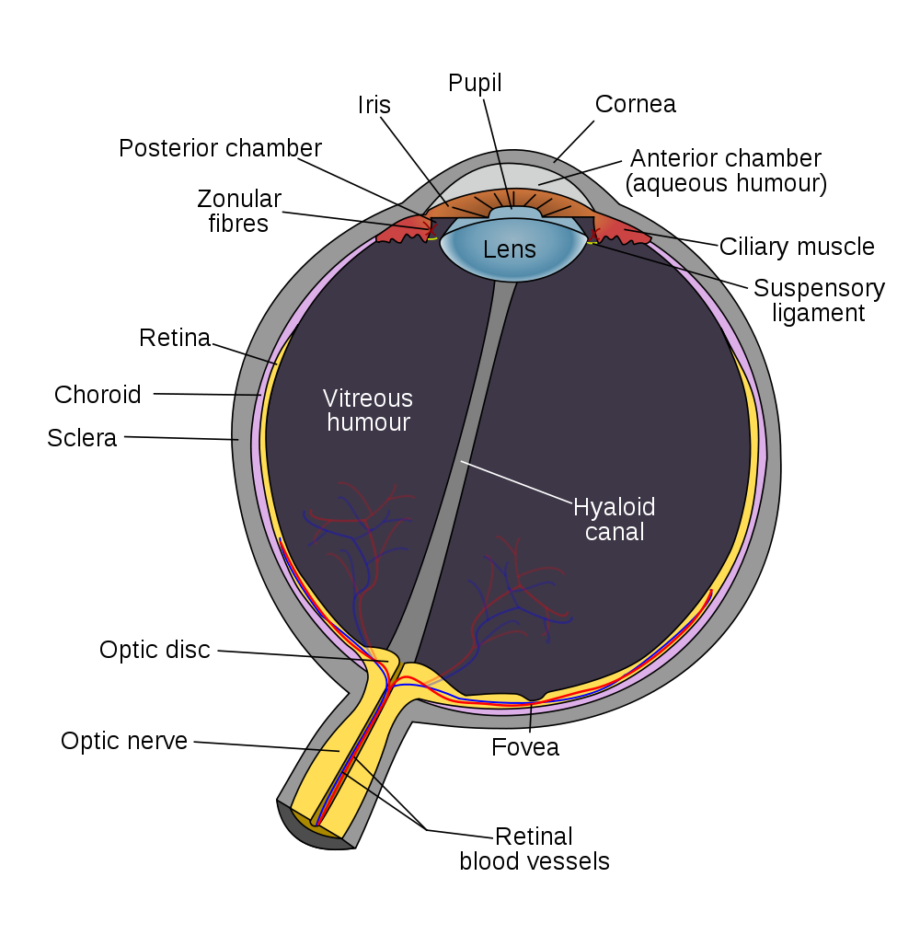Figure 2: The human eye
Usually the ratio of rods over cones is 20:1 (4.5 million cone cells and 90 million rod cells).
However, even if the cones are less sensitive to light than rods, they allow the eye to be sensitive to color, in particular there are three different types of cones in the retina and each one is sensible to a different part of the visible spectrum : The three types of cones are L, M, and S, which have pigments that respond best to light of long (especially 560 nm), medium (530 nm), and short (420 nm) wavelengths respectively, as shown in Figure 3.
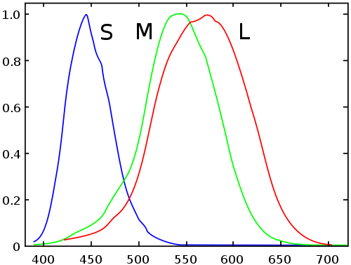Figure 3: S, M and L cones response to different wavelenght stimulus

Sensors, filters and colors
Until now we have seen how the light is “captured” by the human eye, but to explain how a picture is captured by a digital camera, we must understand how the light hits the sensor from the environment.
The main components of any digital camera are the lens and the image sensor . A ray of light hits the lens, which focuses it to a part of the sensor. The energy of the ray is converted in an electronic signal, which in turn is converted to a color value to be stored in a file in the memory card of the camera.
However, color

TODO : images to explain the light and the sensor.

